**Practical-1**

**Aim: Write C program to print all negative elements in an array.**

**Program:**

#include<stdio.h>

main()

{

int i,j,n;

printf("Enter value of array:");

scanf("%d",&n);

int ar[n][n];

for(i=0;i<n;i++)

{

for(j=0;j<n;j++)

{

printf("ar[%d][%d]",i,j);

scanf("%d",&ar[i][j]);

}

}

printf("\n\nArray elements are:\n\n");

for(i=0;i<n;i++)

{

for(j=0;j<n;j++)

{

printf("%d\t",ar[i][j]);

}

printf("\n");

}

printf("\nNegative elements are:\n\n");

for(i=0;i<n;i++)

{

for(j=0;j<n;j++)

{

if(ar[i][j]<0)

{

printf("%d\n",ar[i][j]);

}

}

}

}

**Output:**

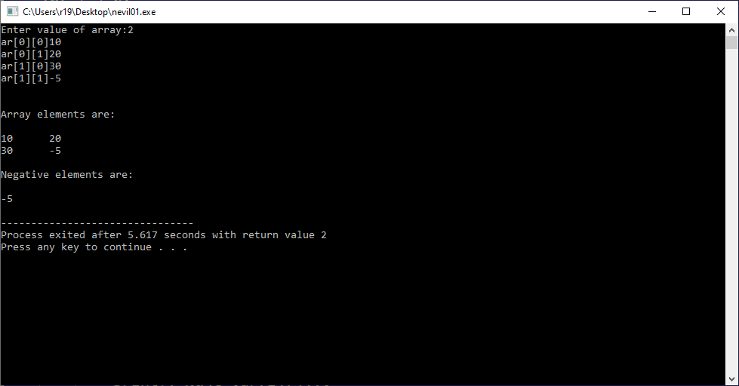

**Practical-2**

**Aim**:**Write C program to find second largest number in array.**

**Program:**

#include<stdio.h>

main()

{

int i,j,n;

int first,second;

printf("Enter value of array:");

scanf("%d",&n);

int ar[50][50];

for(i=0;i<n;i++)

{

for(j=0;j<n;j++)

{

printf("ar[%d][%d]",i,j);

scanf("%d",&ar[i][j]);

}

}

first=second;

for(i=0;i<n;i++)

{

for(j=0;j<n;j++)

{

if(ar[i][j]>first)

{

second=first;

first=ar[i][j];

}

}

}

printf("\n\nthe second largest is=%d",second);

}

**Output:**

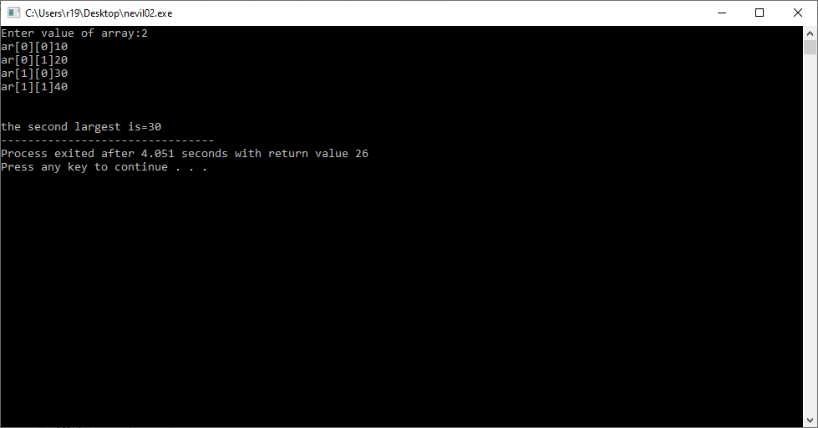

**Practical-3**

**Aim:Write C program to count frequency of each element in an array.**

**Program:**

**Output:**

**Practical-4**

**Aim: Write C program to Insert, Delete & Update operations the element into array.**

**Program:**

**Output:**

**Practical-5**

**Aim:Write C program to left rotate and right rotate an array**

**Program:**

**1.**

#include <conio.h>

int main()

{

int a[10000],i,n,j,k,temp;

printf("Enter size of the array : ");

scanf("%d", &n);

printf("Enter elements in array : ");

for(i=0; i<n; i++)

{

scanf("%d",&a[i]);

}

printf("how many times left rotate : ");

scanf("%d", &k);

for(i=0; i<k; i++)

{

temp=a[n-1];

for(j=n-1; j>0; j--)

{

a[j]=a[j-1];

}

a[j]=temp;

}

printf("\narray elements after left rotate : ");

for(i=0; i<n; i++)

{

printf("%d ",a[i]);

}

}

**2.**

#include <conio.h>

int main()

{

int a[10000],i,n,j,k,temp;

printf("Enter size of the array : ");

scanf("%d", &n);

printf("Enter elements in array : ");

for(i=0; i<n; i++)

{

scanf("%d",&a[i]);

}

printf("how many times left rotate : ");

scanf("%d", &k);

for(i=0; i<k; i++)

{

temp=a[n-1];

for(j=n-1; j>0; j--)

{

a[j]=a[j-1];

}

a[j]=temp;

}

printf("\narray elements after left rotate : ");

for(i=0; i<n; i++)

{

printf("%d ",a[i]);

}

}

**Output:**

**1.**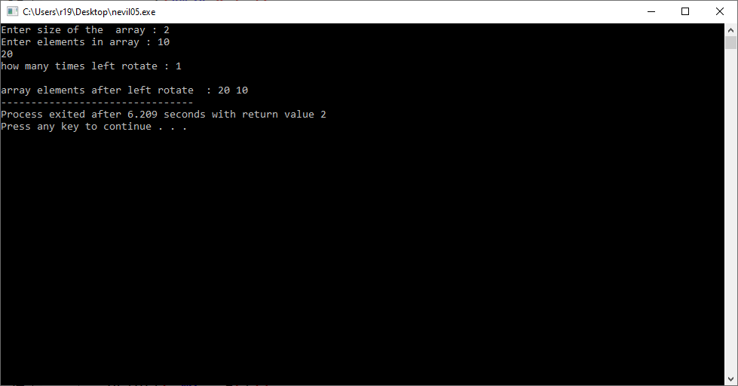

**2.**

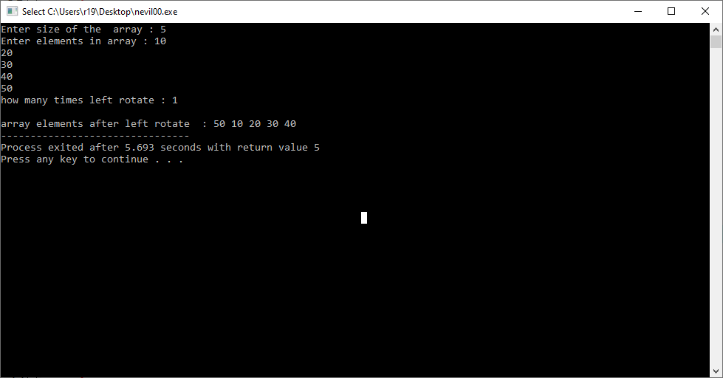

**Practical-6**

**Aim: Write C program to addition of two matrices**

**Program:**

#include<stdio.h>

#define p printf

#define s scanf

main()

{

int a[10],b[10],c[10],j,i,n;

p("enter size of array:");

s("%d",&n);

p("\nenter value of array a:\n");

for(i=0; i<n; i++)

{

s("%d",&a[i]);

}

p("\nenter value of array b:\n");

for(i=0; i<n; i++)

{

s("%d",&b[i]);

}

for(i=0; i<n; i++)

{

c[i]=a[i]+b[i];

}

p("\naddition of two arrays are:\n");

for(i=0; i<n; i++)

{

p("%d\n",c[i]);

}

}

**Output:**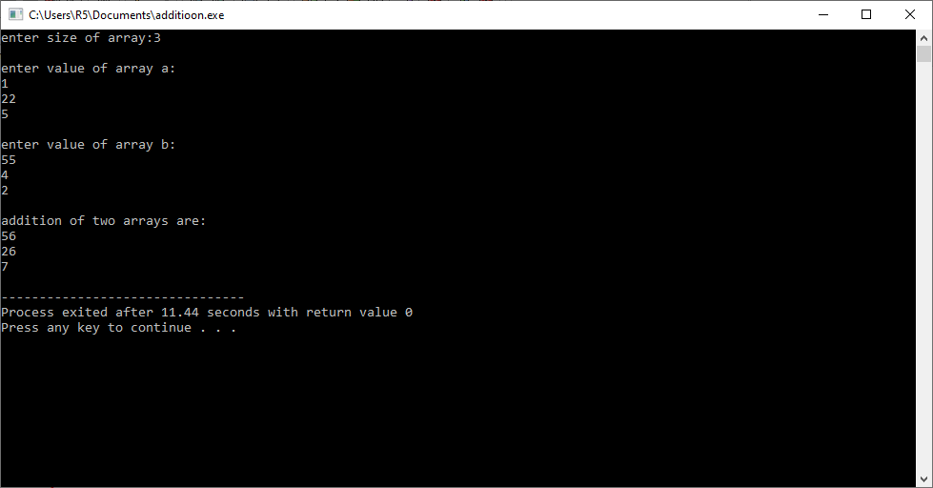

**Practical-7**

**Aim: Write C program matrix convert into transpose matrix.**

**Program:**

#include<stdio.h>

main()

{

int i,j,r,c,sum=0,total;

printf("Enter number of rows:");

scanf("%d",&r);

printf("Enter cols:");

scanf("%d",&c);

int ar[r][c];

for(i=0;i<r;i++)

{

for(j=0;j<c;j++)

{

printf("ar[%d][%d]",i,j);

scanf("%d",&ar[i][j]);

}

}

printf("Original matrix\n\n");

for(i=0;i<r;i++)

{

for(j=0;j<c;j++)

{

printf("%d\t",ar[i][j]);

}

printf("\n");

}

printf("Tranpose matrix\n\n");

for(i=0;i<r;i++)

{

for(j=0;j<c;j++)

{

printf("%d\t",ar[j][i]);

}

printf("\n");

}

}

**Output:**

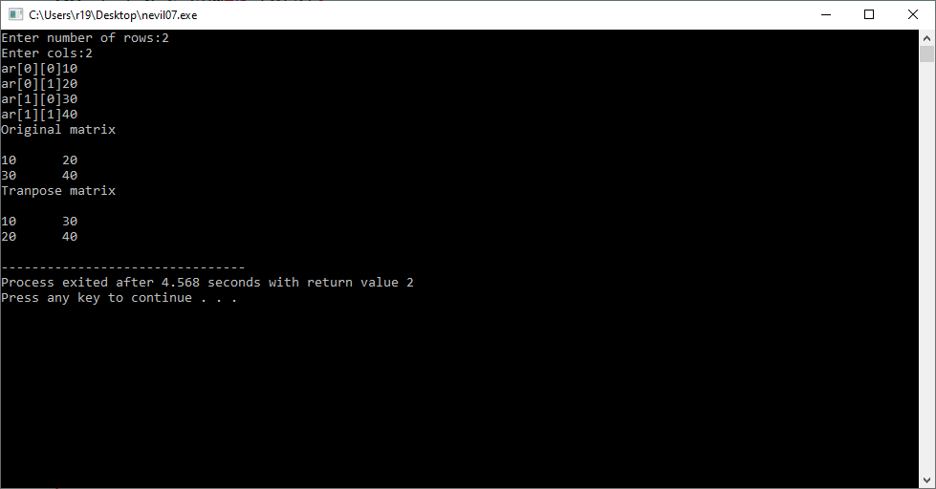

**Practical-8**

**Aim:Write C program to find sum of diagonal elements of a matrix.**

**Program:**

#include<stdio.h>

main()

{

int i,j,r,c,sum=0,total;

printf("Enter number of rows:");

scanf("%d",&r);

printf("Enter cols:");

scanf("%d",&c);

int ar[r][c];

for(i=0;i<r;i++)

{

for(j=0;j<c;j++)

{

printf("ar[%d][%d]",i,j);

scanf("%d",&ar[i][j]);

}

}

printf("\n\nArray elements are:\n\n");

for(i=0;i<r;i++)

{

for(j=0;j<c;j++)

{

printf("%d\t",ar[i][j]);

}

printf("\n");

}

for(i=0;i<r;i++)

{

sum=sum+ar[i][i];

}

printf("\n the sum of diagonal elements is %d",sum);

}

**Output:**